Chapter 8 – Genetics Lesson 1 – Mendel and his Peas
Heredity
Heredity is the passing of traits from parents to offspring. For example, you and your brother might have blue eyes but both of your parents have brown eyes. How does this happen?

More than 150 years ago, Gregor Mendel, an Austrian monk, performed experiments that helped answer many questions about heredity. Mendel is known as the father of genetics.

Genetics is the study of how traits are passed from parents to offspring.
Mendel’s Experimental Methods
During the 1850s, Mendel studied genetics by doing controlled breeding experiments with pea plants.
Pea plants were ideal for genetics studies because:
- Peas reproduce quickly. Mendel was able to grow many plants and collect a lot of data.
- Peas have easily observed traits, such as flower color and pea shape.
- Mendel could control which pairs of plants reproduced. He was able to find out which traits came from which plant pairs.
Pollination in Pea Plants
To observe how a trait was inherited, Mendel controlled which plants pollinated other plants. Pollination occurs when pollen lands on the pistil of a flower. Sperm cells from the pollen then fertilize egg cells in the pistil.
Self-pollination occurs when pollen from one plant lands on the pistil of a flower on the same plant.
Cross-pollination occurs when pollen from one plant reaches the pistil of a flower on a different plant.
Mendel allowed one group of flowers to self-pollinate. With another group, he cross-pollinated the plants himself.

Self-Pollination vs. Cross-Pollination
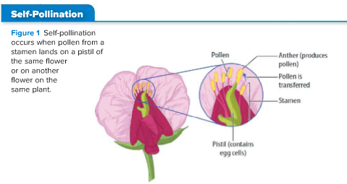
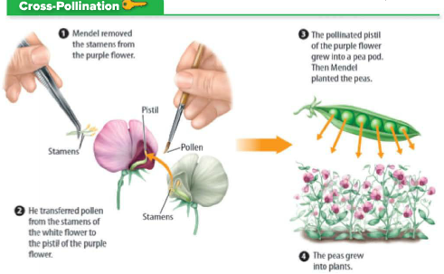

Mendel’s Results
Once Mendel had enough true-breeding plants for a trait that he wanted to test, he cross-pollinated selected plants. His results are described below.

First-Generation Crosses
Crosses between true-breeding plants with purple flowers produced true-breeding plants with only purple flowers.
Crosses between true-breeding plants with white flowers produced true-breeding plants with only white flowers.
However, when Mendel crossed true-breeding plants with purple flowers and true-breeding plants with white flowers, all of the offspring had purple flowers.
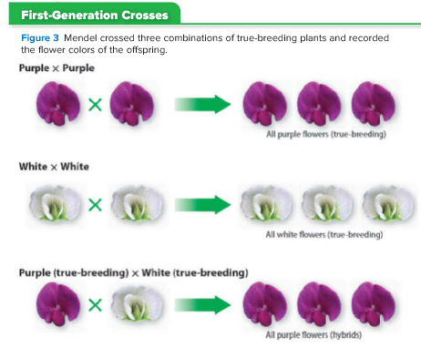

New Questions Raised
Why did crossing plants with purple flowers and plants with white flowers always produce offspring with purple flowers? Why were there no white flowers? Why didn’t the cross produce offspring with pink flowers—a combination of white and purple?

Second-Generation (Hybrid) Crosses
Mendel’s first-generation purple-flowering plants are called hybrid plants. They came from true-breeding parent plants with different forms of the same trait.
When Mendel cross-pollinated two purple-flowering hybrid plants, some of the offspring had white flowers. The trait that had disappeared in the first-generation always reappeared in the second-generation.
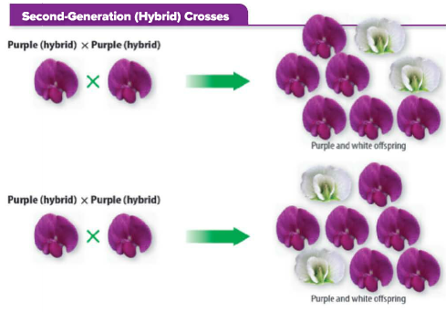
Mendel got similar results each time he cross-pollinated hybrid plants. For example, a true-breeding yellow-seeded pea plant crossed with a true-breeding green-seeded pea plant always produced yellow-seeded hybrids.
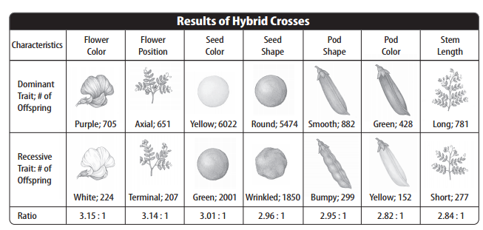
Mendel’s Conclusions
After analyzing the results of his experiments, Mendel concluded that two factors control each inherited trait. He also proposed that when organisms reproduce, the sperm and the egg each contribute one factor for each trait. Mendel’s results are shown in the table above.

Dominant and Recessive Traits
When Mendel cross-pollinated a true-breeding plant with purple flowers and a true-breeding plant with white flowers, the hybrid offspring had only purple flowers. He hypothesized that the hybrid offspring had one genetic factor for purple flowers and one genetic factor for white flowers. But why were there no white flowers?’
Mendel also hypothesized that the purple factor was dominant, blocking the white factor. A genetic factor that blocks another genetic factor is called a dominant trait. A dominant trait, such as purple pea flowers, is seen when offspring have either one or two dominant factors.

A genetic factor that is blocked by the presence of a dominant factor is called a recessive trait. A recessive trait, such as white pea flowers, is seen only when two recessive genetic factors are present in offspring.

From Parents to Second Generation
For the second generation, Mendel cross-pollinated two hybrids that had purple flowers.
About 75 percent of the second-generation plants had purple flowers. These plants had at least one dominant factor.
Twenty-five percent of the second-generation plants had white flowers. These plants had the same two recessive factors.

